Smart Video Reframe: 16:9 to 9:16 Pipeline

Overview of the Approach
The pipeline uses a 5-step process. Instead of simply cropping the centre of each frame, it analyses the video to find where the important subjects are, then creates a smooth camera path that follows them.
- The five steps are:
- Step 1 - Extract key frames from the video at a lower frame rate.
- Step 2 - Detect people, faces, and visually important regions in each frame.
- Step 3 - Build a smooth crop trajectory using optimisation and Kalman filtering.
- Step 4 - Detect scene cuts, apply easing, and interpolate to full frame rate.
- Step 5 - Render the final 9:16 portrait video.

Pipeline Flow
Input Video (16:9) --> [Frame Extraction] --> [Detection & Saliency] --> [Trajectory Optimisation] --> [Easing & Interpolation] --> [Rendering] --> Output Video (9:16)

Output Folder Structure
workspace/
frames/ - sampled frames + metadata.json
analysis/ - detections.json, flow.json, saliency/
trajectory/ - trajectory.json
crop_data/ - crop_commands.json
output_9x16.mp4 - FINAL OUTPUT

How to Run the Pipeline
python run_pipeline.py your_video.mp4
Optional arguments:
python run_pipeline.py input.mp4 --sample-fps 10 --output my_output.mp4
Arguments:
input : Path to the input 16:9 video file
--workspace : Output folder (default: workspace)
--sample-fps : Frames per second to sample (default: 5)
--output : Output filename (default: output_9x16.mp4)
--method : "opencv" or "sendcmd" (default: opencv)

Master Pipeline (run_pipeline.py)
This is the main entry point that calls all five steps in order. It accepts command-line arguments (input video path, sample FPS, etc.), creates the workspace folders, runs each step sequentially, and prints a summary at the end with total time and number of frames processed.
Key points:
- It creates subdirectories: frames/, analysis/, trajectory/, crop_data/ inside workspace/.
- Each step reads output from the previous step via JSON files, making the pipeline modular.
- Times each step and prints a final summary.

Step 1: Frame Extraction (step1_extract_frames.py)

What it does (Simple Explanation)
A video is just a sequence of images (frames) shown very quickly - typically 24 to 30 frames every second. Analysing every single frame would be very slow and unnecessary, because consecutive frames are almost identical. So Step 1 picks out only a few frames per second (e.g., 5 per second instead of 30). These "sampled" frames are saved as JPEG images for the next steps to work on.

Approach
1. Open the video using OpenCV (cv2.VideoCapture).
2. Read the video properties: resolution, FPS, total frame count, duration.
3. Calculate the sampling interval. For example, if the video is 30 FPS and we want 5 samples per second, we pick every 6th frame (30/5 = 6).
4. Loop through all frames; save only the ones at the sampling interval.
5. Save a metadata.json file containing video info and which frame numbers were saved.

Code Explanation
The extract_frames() function opens the video, reads its properties (FPS, resolution, frame count), calculates which frames to sample, then loops through the video saving only the sampled frames as high-quality JPEGs. It uses a set for O(1) lookup of which frame indices to save. Finally it writes a metadata.json file that all subsequent steps will read.
sample_interval = max(1, int(round(original_fps / sample_fps)))
sampled_indices = list(range(0, total_frames, sample_interval))
# Example: for 30fps video with sample_fps=5 -> every 6th frame

Input / Output
Input: Video file (e.g. your_video.mp4)
Output: workspace/frames/frame_000000.jpg, frame_000006.jpg, ... + metadata.json

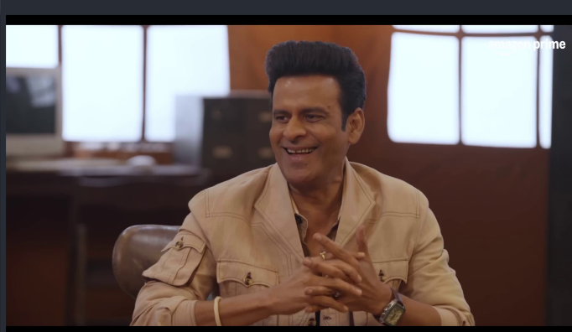
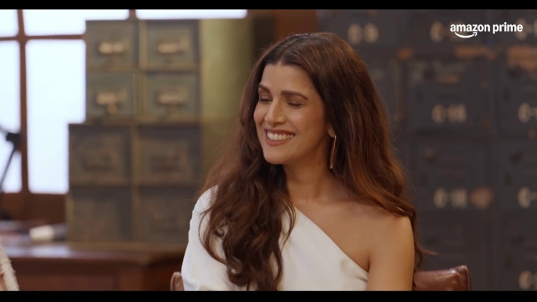
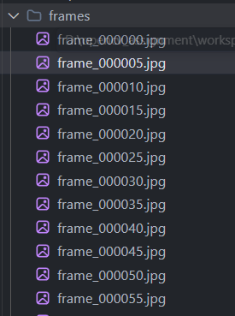

Step 2: Detection + Saliency + Optical Flow (step2_analyze_frames.py)

What it does (Simple Explanation)
For each sampled frame, this step answers three questions:
(a) Where are the people and faces? (Detection)
(b) What parts of the image naturally attract the eye? (Saliency)
(c) Which direction is everything moving? (Optical Flow)
The answers are combined into a single "focus point" - the (x, y) coordinate where the crop window should be centred.

Approach
A) Person Detection (YOLOv8)
YOLOv8-nano is a fast, lightweight object detector. We use it to find bounding boxes around people in each frame (class 0 = person). Only detections with confidence > 40% are kept.
B) Face Detection (Haar Cascade)
OpenCV's built-in Haar cascade classifier detects faces. It works by scanning the image at multiple scales looking for face-like patterns. Faces get the highest priority weight (60%) when computing the focus point, because in most videos the face is what viewers care about most.
C) Saliency Map (Spectral Residual)
A saliency map highlights which parts of an image are visually "interesting" - bright colours, high contrast, or unusual textures. OpenCV's Spectral Residual method converts the image to the frequency domain, finds the "unexpected" frequencies, and produces a heatmap. The brightest point on this map is the saliency peak.
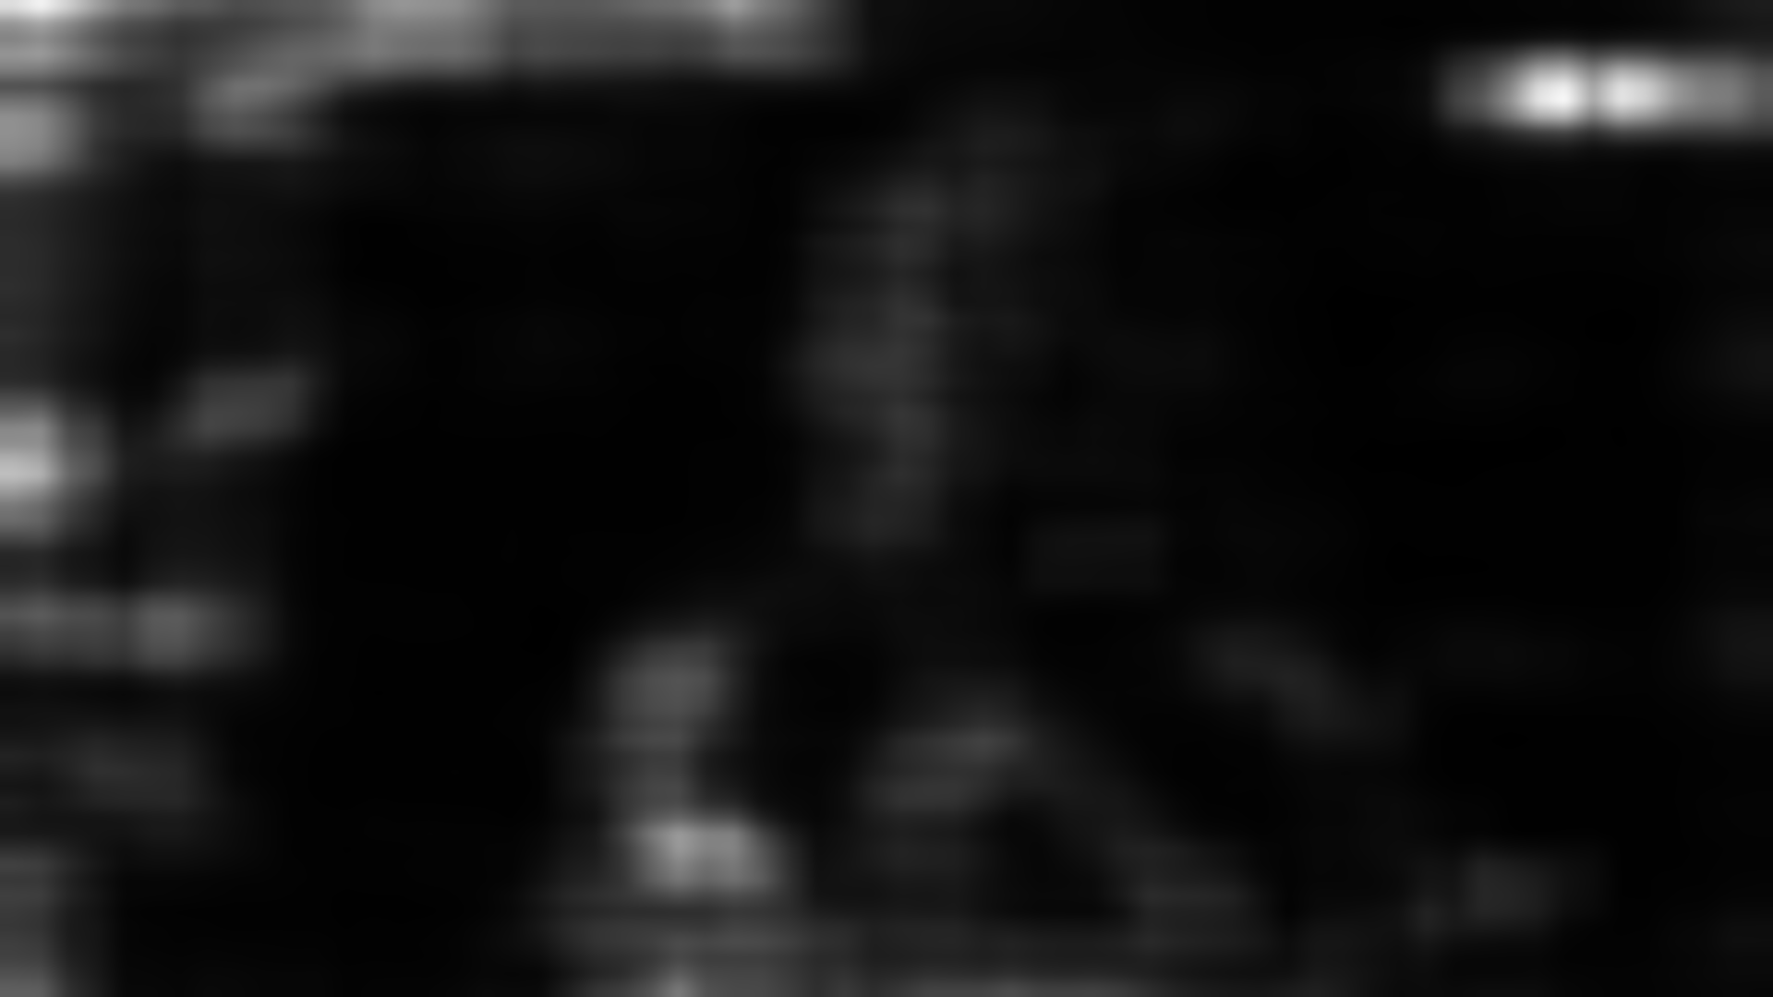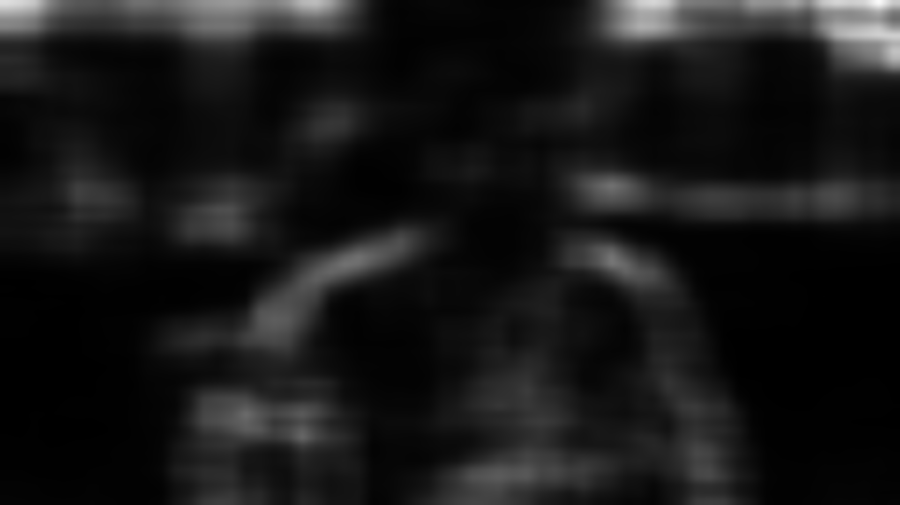

D) Optical Flow (Farneback)
Optical flow measures how pixels move between two consecutive frames. The Farneback method computes a motion vector (dx, dy) for every pixel. We take the median motion to get the dominant movement direction. This helps the crop "lead" moving subjects instead of lagging behind.
E) Weighted Focus Point
All detections are blended into one focus point using weights:
- Faces: 60% weight (highest priority)
- Person bodies: 25% weight
- Saliency peak: 15% weight (fallback)
The result is a single (x, y) coordinate per frame.

Code Explanation
The analyze_frames() function loads metadata from Step 1, initialises YOLOv8 and the Haar cascade, then loops over all sampled frames. For each frame it: (1) computes a saliency map and finds its peak, (2) runs YOLO to detect persons, (3) runs Haar cascade to detect faces, (4) computes a weighted average focus point, and (5) computes optical flow vs the previous frame. Results are saved as detections.json and flow.json.
# Weighted focus point formula:
focus = (face_centres * 0.60 + person_centres * 0.25 + saliency_peak * 0.15)

Step 3: Trajectory Optimisation + Kalman Smoothing (step3_trajectory.py)

What it does (Simple Explanation)
The raw focus points from Step 2 can be noisy and jumpy. If we used them directly, the crop window would shake and jitter. Step 3 smooths these points into a gentle, stable camera path using two techniques:
(a) Global Optimisation - finds the best overall path.
(b) Kalman Filter - adds physics-based smoothing (like a camera on a gimbal).

Approach
A) Crop Window Size Calculation
For a 9:16 portrait crop from a 1920x1080 video:
crop_width = 1080 * (9/16) = 607 pixels
crop_height = 1080 pixels (full height)
The crop centre X must stay within [304, 1616] so the window never goes outside the frame.
B) Global Optimisation (L-BFGS-B)
We define a cost function with two competing goals:
1. Stay close to the raw focus points (so we track subjects)
2. Minimise frame-to-frame jumps (so the camera is smooth)
scipy.optimize.minimize finds the best balance across ALL frames at once. The lambda weights control the trade-off: higher jitter penalty = smoother path.
Cost = sum( LAMBDA_DIST * (x[i] - raw_x[i])^2
+ LAMBDA_JITTER * (x[i] - x[i-1])^2 )
C) Gaussian Smoothing
A Gaussian filter (sigma=2) is applied as a first-pass smoother to remove high-frequency noise from the optimised trajectory.
D) Kalman Filter
A 1D constant-velocity Kalman filter treats the crop position as a physical object with position and velocity. It predicts where the crop should be next based on its current speed, then corrects using the actual measurement. This gives a very natural, gimbal-like motion.

Code Explanation
build_trajectory() loads the raw focus points and optical flow data. It first adds a flow-based "lead" bias (anticipating subject movement), then runs L-BFGS-B optimisation, Gaussian smoothing, and finally the Kalman filter. The result is a smooth (smooth_x, smooth_y) per frame, saved as trajectory.json.

Step 4: Scene Cuts + Easing + Interpolation (step4_easing_interpolation.py)

What it does (Simple Explanation)
Step 3 only produced crop positions for the sampled frames (e.g., every 5th frame). Step 4 fills in the gaps for ALL original frames using cubic spline interpolation. It also detects scene cuts (hard transitions) so the crop can jump instantly at cuts instead of smoothly sliding. Finally, it applies "easing" to make camera movements feel cinematic (slow start, fast middle, slow end).

Approach
A) Scene Cut Detection
Consecutive frames are compared using colour histograms (HSV). If the histogram correlation drops below 0.45, a scene cut is detected. At scene cuts, the crop position should jump immediately rather than interpolate.
B) Easing Functions
Within each scene (between cuts), an ease-in-out cubic function is applied. This remaps time so the crop movement starts slowly, speeds up in the middle, and slows down at the end - just like a real camera operator would move. A speed limiter caps maximum movement to 6 pixels per frame to prevent jarring jumps.
# Ease-in-out cubic:
if t < 0.5: result = 4 * t^3
else: result = 1 - (-2*t + 2)^3 / 2
C) Cubic Spline Interpolation
A cubic spline is fitted through the keyframe crop positions. This gives a smooth curve that is evaluated at every single original frame, producing crop_x, crop_y, crop_w, crop_h for each frame.

Code Explanation
build_crop_commands() loads the trajectory and metadata, detects scene cuts via histogram comparison, applies easing within each scene segment, then uses scipy CubicSpline to interpolate to full FPS. The centre_to_crop() function converts each (cx, cy) centre point into a top-left corner with clamping. The result is crop_commands.json with one entry per original frame.

Step 5: Rendering the Final Video (step5_render.py)

What it does (Simple Explanation)
This step reads the original video frame by frame, applies the crop from crop_commands.json, resizes each cropped frame to 1080x1920 (Full HD portrait), and writes the final output video. The original audio is preserved.

Approach
Two rendering methods are available:
Method A: OpenCV (Default, Recommended)
1. Open the original video with OpenCV.
2. For each frame, look up its crop rectangle from crop_commands.
3. Crop the frame using NumPy array slicing: frame[y:y+h, x:x+w].
4. Resize to 1080x1920 using Lanczos interpolation (best quality).
5. Write to a temporary video file.
6. Use FFmpeg to mux (combine) the video with audio from the original.
Method B: FFmpeg sendcmd (Advanced)
Generates a text file of timestamped crop commands and passes it to FFmpeg's sendcmd filter. Faster but less reliable across codecs.

Code Explanation
render_final_video() loads metadata and crop commands, then calls either render_with_opencv() or render_with_ffmpeg_sendcmd(). The OpenCV method reads each frame, applies the variable crop, resizes with INTER_LANCZOS4, writes to a temp file, then uses subprocess to call FFmpeg for audio muxing. The temp file is deleted after muxing.

Libraries and Dependencies
Library | Purpose
OpenCV (cv2) | Video reading/writing, image processing, face detection, saliency, optical flow.
Ultralytics (YOLOv8) | State-of-the-art object detection to find people in frames.
NumPy | Fast array operations for image manipulation and mathematical computations.
SciPy | L-BFGS-B optimisation (trajectory), cubic spline interpolation, Gaussian filter.
FilterPy | Kalman filter implementation for smooth trajectory estimation.
tqdm | Progress bars for long-running loops.
FFmpeg (external) | Video encoding and audio muxing via subprocess calls.

Summary
This pipeline takes any standard landscape video and intelligently converts it to portrait format by:
1. Sampling key frames to save processing time.
2. Using AI (YOLO) and computer vision (saliency, optical flow) to find where important subjects are.
3. Optimising and smoothing the crop path so the camera movement looks professional and stable.
4. Applying cinematic easing and handling scene cuts gracefully.
5. Rendering the final high-quality portrait video with original audio.
The result is a broadcast-quality 9:16 video that keeps subjects centred and visible throughout, with smooth, professional camera movements.

